Supplementary material

Supplementary Table 1. STROBE Statement—checklist of items that should be included in reports of observational studies.
 | Item No. | Recommendation | Page  No. | Relevant text from manuscript
Title and abstract | 1 | (a) Indicate the study’s design with a commonly used term in the title or the abstract | 1
 |  | (b) Provide in the abstract an informative and balanced summary of what was done and what was found | 1–2
Introduction
Background/rationale | 2 | Explain the scientific background and rationale for the investigation being reported | 2
Objectives | 3 | State specific objectives, including any prespecified hypotheses | 2 | Accordingly, we tested a hypothesis that the administration of diuretics during the first 24 hours would reduce AKI progression between 24 and 72 hours among postoperative cardiac surgery patients based on the data of a multicenter retrospective cohort study.
Methods
Study design | 4 | Present key elements of study design early in the paper | 2–5 | This study is a post-hoc analysis of a multicenter retrospective cohort study enrolling adult patients after cardiac surgery in 14 ICUs in Japan (BROTHER study; UMIN-CTR; trial ID: UMIN000037074).
Setting | 5 | Describe the setting, locations, and relevant dates, including periods of recruitment, exposure, follow-up, and data collection | 3 | This study is a post-hoc analysis of a multicenter retrospective cohort study enrolling adult patients after cardiac surgery in 14 ICUs in Japan (BROTHER study; UMIN-CTR; trial ID: UMIN000037074).  We consecutively enrolled patients aged 18 years or older admitted to the ICU after elective coronary artery bypass grafting (CABG) or valve surgery between 01 January and 31 December 2018.
Participants | 6 | (a) Cohort study—Give the eligibility criteria, and the sources and methods of selection of participants. Describe methods of follow-up  Case-control study—Give the eligibility criteria, and the sources and methods of case ascertainment and control selection. Give the rationale for the choice of cases and controls  Cross-sectional study—Give the eligibility criteria, and the sources and methods of selection of participants | 3 | Participants and data sources/measurement
 |  | (b) Cohort study—For matched studies, give matching criteria and number of exposed and unexposed  Case-control study—For matched studies, give matching criteria and the number of controls per case | N/A
Variables | 7 | Clearly define all outcomes, exposures, predictors, potential confounders, and effect modifiers. Give diagnostic criteria, if applicable | 3–4 | Exposure and outcome variables
Data sources/measurement | 8* | For each variable of interest, give sources of data and details of methods of assessment (measurement). Describe comparability of assessment methods if there is more than one group | 3 | Exposure and outcome variables
Bias | 9 | Describe any efforts to address potential sources of bias | 4 | Statistical analysis
Study size | 10 | Explain how the study size was arrived at | N/A
Quantitative variables | 11 | Explain how quantitative variables were handled in the analyses. If applicable, describe which groupings were chosen and why | 4–5 | Statistical analysis
Statistical methods | 12 | (a) Describe all statistical methods, including those used to control for confounding | 4–5 | Statistical analysis
 |  | (b) Describe any methods used to examine subgroups and interactions | 4–5 | We conducted the following sensitivity analyses (1) excluding patients who received human natriuretic atrial peptide during the first 24 hours because it may worsen renal function after cardiac surgery (20), (2) including only patients with intraoperative fluid balance >5% of the body weight due to its association with AKI progression in cardiac surgery patients (21), and (3) including only patients receiving any vasopressor or inotrope during the first 24 hours after ICU admission considering the association between shock and AKI (19).
 |  | (c) Explain how missing data were addressed | 4 | In all variables except for CVP, we reported the number of missing data if there were missing data, and each analysis was done without cases with missing data.
 |  | (d) Cohort study—If applicable, explain how loss to follow-up was addressed  Case-control study—If applicable, explain how matching of cases and controls was addressed  Cross-sectional study—If applicable, describe analytical methods taking account of sampling strategy | N/A
 |  | (e) Describe any sensitivity analyses | 5 | Same as 12 (b)
Results
Participants | 13* | (a) Report numbers of individuals at each stage of study—eg, numbers potentially eligible, examined for eligibility, confirmed eligible, included in the study, completing follow-up, and analysed | 5 | Among 1568 adult patients admitted to the ICUs after cardiac surgery between January and December 2018, 870 patients were registered in the BROTHER study. After excluding 152 patients, 718 were eligible for this post-hoc analysis (Fig. 1). No patients were lost to follow-up.
 |  | (b) Give reasons for non-participation at each stage | 5
 |  | (c) Consider use of a flow diagram | Fig. 1
Descriptive data | 14* | (a) Give characteristics of study participants (eg, demographic, clinical, social) and information on exposures and potential confounders | 5  Table 1 | Table 1 describes preoperative patient characteristics and perioperative management.
 |  | (b) Indicate number of participants with missing data for each variable of interest | Table 1
 |  | (c) Cohort study—Summarise follow-up time (eg, average and total amount) | 5
Outcome data | 15* | Cohort study—Report numbers of outcome events or summary measures over time | 5 | The primary outcome, AKI progression, occurred in 115 patients (16%).
 |  | Case-control study—Report numbers in each exposure category, or summary measures of exposure | N/A
 |  | Cross-sectional study—Report numbers of outcome events or summary measures | N/A
Main results | 16 | (a) Give unadjusted estimates and, if applicable, confounder-adjusted estimates and their precision (eg, 95% confidence interval). Make clear which confounders were adjusted for and why they were included | Tables 3 and 4
 |  | (b) Report category boundaries when continuous variables were categorized | Table 1
 |  | (c) If relevant, consider translating estimates of relative risk into absolute risk for a meaningful time period | N/A
Other analyses | 17 | Report other analyses done—eg, analyses of subgroups and interactions, and sensitivity analyses | 5  Table 4 | The sensitivity analyses found similar results with the primary analysis.
Discussion
Key results | 18 | Summarise key results with reference to study objectives | 6 | Key findings
Limitations | 19 | Discuss limitations of the study, taking into account sources of potential bias or imprecision. Discuss both direction and magnitude of any potential bias | 7 | Strengths and limitations
Interpretation | 20 | Give a cautious overall interpretation of results considering objectives, limitations, multiplicity of analyses, results from similar studies, and other relevant evidence | 6–7 | Relationship with previous studies
Generalisability | 21 | Discuss the generalisability (external validity) of the study results | 6–7 | Significance and implications
Other information
Funding | 22 | Give the source of funding and the role of the funders for the present study and, if applicable, for the original study on which the present article is based | 9 | This study received no external funding or financial support from any organization or agency.
*Give information separately for cases and controls in case-control studies and, if applicable, for exposed and unexposed groups in cohort and cross-sectional studies.
Note: An Explanation and Elaboration article discusses each checklist item and gives methodological background and published examples of transparent reporting. The STROBE checklist is best used in conjunction with this article (freely available on the Web sites of PLoS Medicine at http://www.plosmedicine.org/, Annals of Internal Medicine at http://www.annals.org/, and Epidemiology at http://www.epidem.com/). Information on the STROBE Initiative is available at https://www.strobe-statement.org/.

Supplementary Table 2. The protocol to estimate preoperative CVP.
1. We estimated preoperative CVP based on inferior vena cava (IVC) diameter and collapsibility at the preoperative echocardiography.
• Preoperative CVP = 3 mmHg if IVC diameter ≤21 mm with >50% collapsibility.
• Preoperative CVP = 8 mmHg if IVC diameter >21 mm with >50% collapsibility, or if IVC diameter ≤21 mm with ≤50% collapsibility.
• Preoperative CVP = 15 mmHg if IVC diameter >21 mm with ≤50% collapsibility.
2. If preoperative echocardiography is not available, we estimated preoperative CVP as 8 mmHg in patients undergoing valve surgery considering that there is at least moderate valvular dysfunction.
3. If there was no preoperative echocardiography and the patient received coronary artery bypass grafting without valve surgery, we estimated the preoperative CVP of 6 mmHg.
CVP: central venous pressure.

Supplementary Table 3. Details on preoperative patient characteristics and perioperative management.
 |  | All  N = 718 | Early diuretics  N = 335 | Non-early diuretics  N = 383 | p value
Body mass index, kg/m² |  | 23 (21–26) | 24 (21–26) | 23 (21–26) | 0.62
Diabetes mellitus, n (%) |  | 167 (23) | 82 (24) | 85 (22) | 0.53
Dyslipidemia |  | 317 (43) | 138 (41) | 179 (47) | 0.16
Ischemic heart disease, n (%) |  | 261 (35) | 114 (34) | 147 (38) | 0.26
Chronic heart failure, n (%) |  | 17 (2.3) | 3 (0.9) | 14 (3.7) | 0.024
Liver cirrhosis |  | 2 (0.3) | 2 (0.6) | 0 | 0.22
Liver failure |  | 1 (0.1) | 1 (0.3) | 0 | 0.47
Leukemia/myeloma |  | 3 (0.4) | 0 | 3 (0.8) | 0.25
Immunosuppression |  | 3 (0.4) | 2 (0.6) | 1 (0.3) | 0.60
Intraoperative RBC transfusion, units |  | 4 (0–6) | 4 (0–6) | 4 (0–6) | 0.28
Intraoperative FFP transfusion, units |  | 4 (0–8) | 4 (0–8) | 4 (0–8) | 0.007
Intraoperative platelet transfusion, units |  | 0 (0–10) | 0 (0–10) | 0 (0–10) | 0.12
Intraoperative hemorrhage, mL |  | 300 (150–620) | 300 (160–612) | 300 (140–643) | 0.45
Sequential Organ Failure Assessment score |  | 7 (6–8) | 7 (6–8) | 7 (6–8) | <0.001
Blood products within the first 24 hours after ICU admission, n (%)
 | RBC | 160 (22) | 84 (25) | 76 (20) | 0.11
 | FFP | 220 (30) | 126 (38) | 94 (25) | <0.001
 | Platelets | 91 (12) | 59 (18) | 32 (8.4) | <0.001
AKI: acute kidney injury; RBC: red blood cell; FFP: fresh frozen plasma; ICU: intensive care unit.
Supplementary Table 4. Acute kidney injury stages before and after 24 hours of intensive care unit stay.
Worst AKI stage, n (%) |  | ICU admission to 24 hours |  |  | 24 to 72 hours
 |  | Early diuretics  N = 335 | Non-early diuretics  N = 383 | p value | Early diuretics  N = 335 | Non-early diuretics  N = 383 | p value
Overall
 | No AKI | 232 (69) | 270 (70) | 0.66 | 240 (72) | 284 (74) | 0.89
 | Stage 1 | 89 (27) | 93 (24) |  | 62 (19) | 66 (17)
 | Stage 2 | 14 (4.2) | 20 (5.2) |  | 30 (9.0) | 30 (7.8)
 | Stage 3 | 0 | 0 |  | 3 (0.9) | 3 (0.8)
Serum creatinine criteria
 | No AKI | 266 (79) | 307 (80) | 0.51 | 280 (84) | 326 (85) | 0.53
 | Stage 1 | 66 (20) | 69 (18) |  | 41 (12) | 48 (13)
 | Stage 2 | 3 (0.9) | 7 (1.8) |  | 12 (3.6) | 7 (1.8)
 | Stage 3 | 0 | 0 |  | 2 (0.6) | 2 (0.5)
Urine output criteria
 | No AKI | 287 (86) | 331 (86) | 0.94 | 275 (82) | 311 (81) | 0.86
 | Stage 1 | 36 (11) | 38 (9.9) |  | 38 (11) | 44 (11)
 | Stage 2 | 12 (3.6) | 14 (3.7) |  | 20 (6.0) | 27 (7.0)
 | Stage 3 | 0 | 0 |  | 2 (0.6) | 1 (0.3)
AKI: acute kidney injury.
Initiation of kidney replacement therapy was included in serum creatinine criteria.

Supplementary Table 5. Acute kidney injury stages according to acute kidney injury progression.
Worst AKI stage, n (%) |  | ICU admission to 24 hours |  |  | 24 to 72 hours
 |  | AKI progression  N = 115 | Non-AKI progression  N = 603 | p value | AKI progression  N = 115 | Non-AKI progression  N = 603 | p value
Overall
 | No AKI | 83 (72) | 419 (69) | 0.81 | 0 | 524 (87) | <0.001
 | Stage 1 | 28 (24) | 154 (26) |  | 64 (56) | 64 (11)
 | Stage 2 | 4 (3.5) | 30 (5.0) |  | 45 (39) | 15 (2.5)
 | Stage 3 | 0 | 0 |  | 6 (5.2) | 0
Serum creatinine criteria
 | No AKI | 91 (79) | 482 (80) | 0.44 | 61 (53) | 545 (90) | <0.001
 | Stage 1 | 21 (18) | 114 (19) |  | 38 (33) | 51 (8.5)
 | Stage 2 | 3 (2.6) | 7 (1.2) |  | 12 (10) | 7 (1.2)
 | Stage 3 | 0 | 0 |  | 4 (3.5) | 0
Urine output criteria
 | No AKI | 100 (87) | 518 (86) | 0.92 | 27 (23) | 559 (93) | <0.001
 | Stage 1 | 12 (10) | 62 (10) |  | 48 (42) | 34 (5.6)
 | Stage 2 | 3 (2.6) | 23 (3.8) |  | 37 (32) | 10 (1.7)
 | Stage 3 | 0 | 0 |  | 3 (2.6) | 0
AKI: acute kidney injury.
Initiation of kidney replacement therapy was included in serum creatinine criteria.
Supplementary Table 6. Increase in acute kidney injury stages in patients with acute kidney injury progression.
AKI stage increase, n (%) |  | AKI progression  N = 115
Overall
 | 1 | 95 (83)
 | 2 | 19 (17)
 | 3 | 1 (0.9)
Serum creatinine criteria
No change or improvement |  | 68 (59)
 | 1 | 42 (37)
 | 2 | 4 (3.5)
 | 3 | 1 (0.9)
Urine output criteria
No change or improvement |  | 29 (25)
 | 1 | 59 (51)
 | 2 | 26 (23)
 | 3 | 1 (0.9)
AKI: acute kidney injury.

Supplementary Table 7. Multivariable analyses for the secondary outcomes.
Secondary outcomes | Odds ratio  (95% confidence interval) | Coefficient  (95% confidence interval) | p value
MAKE30 | 1.51 (0.25 to 9.12) |  | 0.66
Hospital mortality | 3.51 (0.22 to 55.9) |  | 0.38
Need for KRT during ICU stay | Not availableª |  | Not availableª
Fluid balance on the second day of ICU stay, mL |  | −182 (−333 to −29) | 0.019
Fluid balance on the third day of ICU stay^{b}, mL |  | 268 (115 to 421) | <0.001
Length of ICU stay, day |  | −0.3 (−0.7 to 0.2) | 0.22
Length of hospital stay, day |  | 2.3 (0.1 to 4.5) | 0.045
Length of mechanical ventilation in ICU, hour |  | −2.1 (−5.7 to 1.6) | 0.26
New-onset atrial fibrillation during ICU stay^{c} | 0.65 (0.39 to 1.08) |  | 0.096
Stroke during hospital stay | 1.89 (0.54 to 6.58) |  | 0.32
ª Due to overfitting.
^{b} Patients who stayed in the ICU over three calendar days or more (N = 706 for the overall population, N = 329 for early diuretics, and N = 377 for non-early diuretics).
^{c} Patients without a history of atrial fibrillation before ICU admission (N = 557 for the overall population, N = 254 for early diuretics, and N = 303 for non-early diuretics).

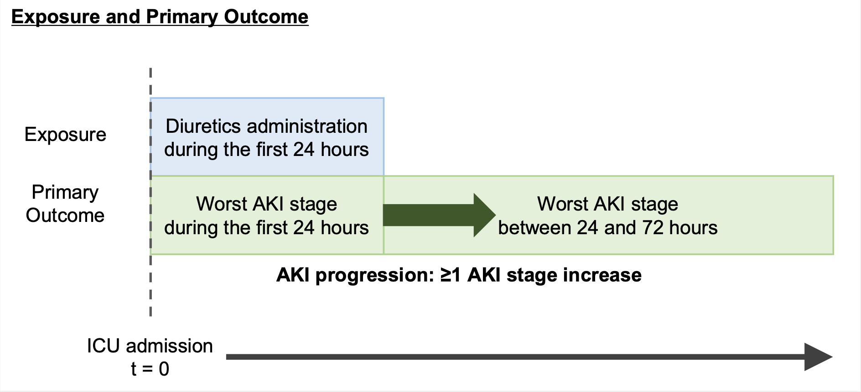
Supplementary Fig. 1. Study design. AKI: acute kidney injury.

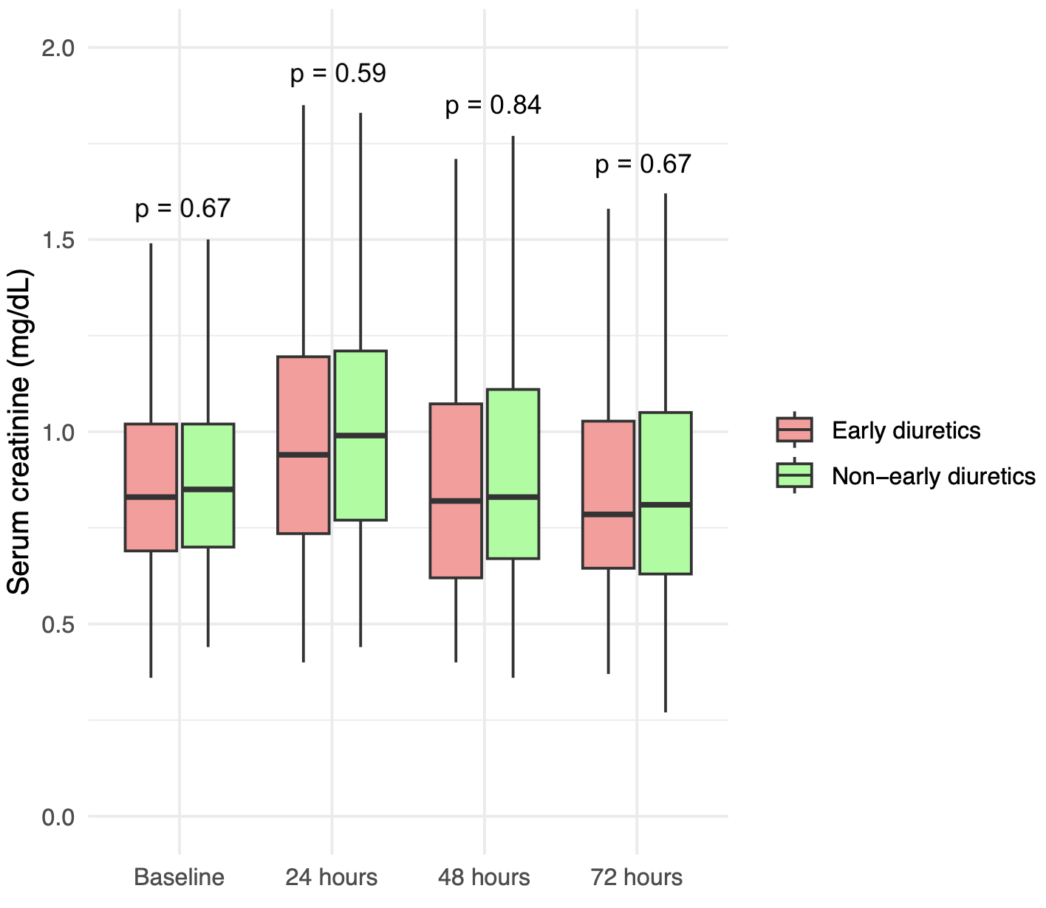
Supplementary Fig. 2. Serum creatinine levels at baseline and during 24 and 72 hours of ICU admission.

